**Change Request Form**

* Project Name:
* Submitted by:
* Submitted on:
* Brief Description:
* Detailed Description:

If a change needs to be made, one must first fill out the information required above. The change request will then be evaluated and executed accordingly.

**Change Request Log (using Github issues)**

* Change request number (Auto Generated)
* Impact analysis (Written in description)
* Estimation of effort (Written in description)
* Submission date (Auto Generated)
* Submitted by (Auto Generated)
* Priority (Issue labels)

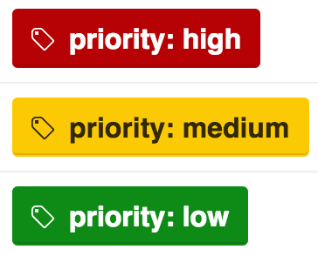

* Status (Issue labels)

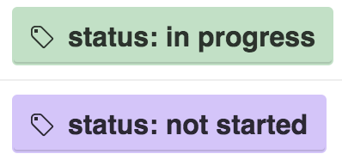

* Assigned to (Assignee field on issues form)
* Resolve date (Close issue)

Example:

